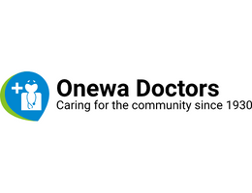

CHRISTMAS SHUTDOWN

We will be closed from the 23rd of December to 7th January 2024.

Don’t leave it too late to book an appointment!

We hope you have a lovely Christmas break!

GET SUMMER READY

Move more, sit less!

Be sun safe – wear and reapply sunscreen every 2 hours!

Don’t stay out in the sun all day

Drink lots of water

Enjoy in season fruits and vegetables

NOVEMBER 2023

General Notices

If you have COVID symptoms please do a RAT test prior to your appointment and email us a photo of the test result. We only do VIRTUAL consults for COVID positive patient.

We are updating our records and you may be asked to provide a photo ID and proof of eligibility. Sorry for the inconvenience!

If you would like to make an appointment or have a query, ring us on 09 4183832 or email [nurse@onewadoctors.com](mailto:nurse@onewadoctors.com) or [reception@onewadoctors.com](mailto:reception@onewadoctors.com)

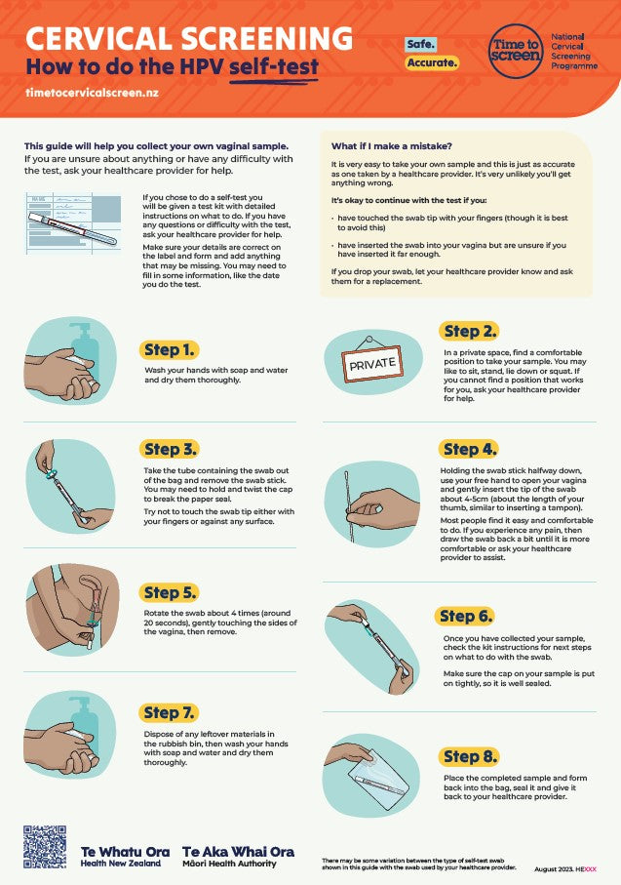

Cervical Screening

Have you heard about the new screening program?

Look out for this instruction sheet at the doctors for more information



Travel advice

Planning to travel this summer? Need medication or have concerns?

Book a travel appointment with us.

There is a pre-travel consultation form that needs to be filled out. Ask us at reception!

Some House Keeping

Normal consultation is only for 15 minutes. Extended consultations incurs an additional fee. Please notify us when booking if you need a longer appointment.

All fees must be paid on the day. Fees not paid on the day incurs an additional account fee.

For all new patients, first visit fee applies. Enquire at reception.